# Assignment 4

Assignment 0

1. Create a simple shell script to tell the user about their session – they

need to know:

● What their username is

● What the current date is

● What the time is

● What their current working directory is

● How many files they have in that directory

● What is the biggest file in their current directory

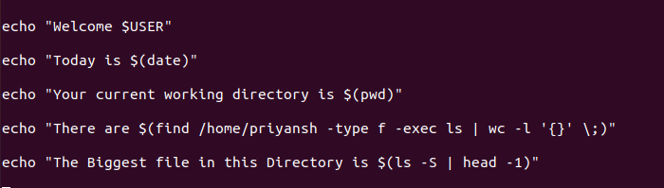

Assignment 2

Write a script that takes a number as an input and reverses it out to the user. For example, if the

original number is 74985, the output should be 58947.

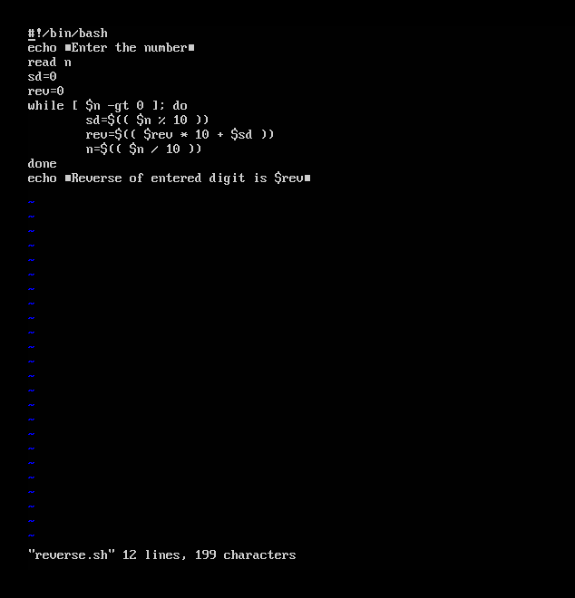

**Output**

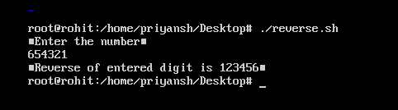

Assignment 3

Write a script to validate how secure someone's password is. Things you would care about:

● Length should be 8 or more characters

● The password should contain numbers and letters

● There should be both uppercase and lowercase letters

**Script**

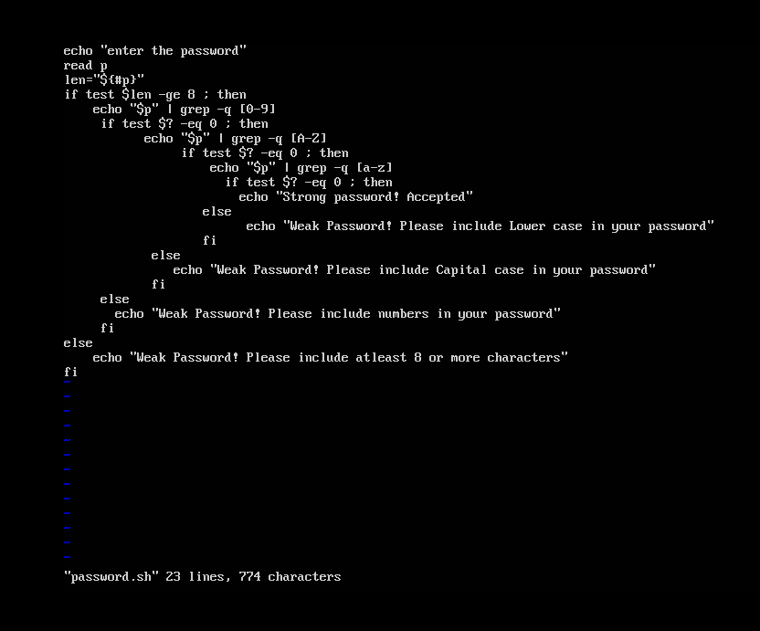

**Output**

